**Public-Key Infrastructure (PKI) Lab**

**Task 1:** **Becoming a Certificate Authority (CA)**

Copy the configuration file into current directory:

cp /usr/lib/ssl/openssl.cnf ./openssl.cnf

create new sub-directories and files according to what it specifies in its [ CA_default ] section:

dir = ./demoCA # Where everything is kept

certs = $dir/certs # Where the issued certs are kept

crl_dir = $dir/crl # Where the issued crl are kept

new_certs_dir = $dir/newcerts # default place for new certs.

database = $dir/index.txt # database index file.

serial = $dir/serial # The current serial number

Simply create an empty file for index.txt, put a single number in string format in serial:

mkdir ./demoCA

cd ./demoCA

mkdir certs

mkdir crl

mkdir newcerts

touch index.txt

echo "1000" > serial

Start to generate the self-signed certificate for the CA:

# return to the parent directory

# cd ..

openssl req -new -x509 -keyout ca.key -out ca.crt -config openssl.cnf

Notice that we apply policy_match in openssl.cnf, so we should keep some fields the same when creating certificates for CA and servers:

[ policy_match ]

countryName= match

stateOrProvinceName = match

organizationName = match

organizationalUnitName = optional

commonName = supplied

emailAddress = optional

When asked to type PEM pass phrase, remember the password you typed (e.g. I use 114514). It will then ask you to fill in some information, you can skip it by Enter, except for those required by policy_match.

The output of the command are stored in two files: ca.key and ca.crt. The file ca.key contains the CA’s **private key**, while ca.crt contains the **public-key certificate**.

**Task 2: Creating a Certificate for SEEDPKILab2020.com**

As a root CA, we are ready to sign a digital certificate for SEEDPKILab2020.com.

**Step 1: Generate public/private key pair**

Generate an RSA key pair. Provide a pass phrase (e.g. I use soudayo) to encrypt the private key in server.key using AES-128 encryption algorithm.

openssl genrsa -aes128 -out server.key 1024

To see the actual content in server.key (pass phrase required):

openssl rsa -in server.key -text

**Step 2: Generate a Certificate Signing Request (CSR)**

Use SEEDPKILab2020.com as the common name of the certificate request

openssl req -new -key server.key -out server.csr -config openssl.cnf

Skip the unnecessary information as well, keep the necessary information (required by policy_match consistent with the CA.crt created in [Task 1](https://github.com/li-xin-yi/seedlab/tree/master/PKI#task-1)).

Now, the new Certificate Signing Request is saved in server.csr, which basically includes the company's public key.

The CSR will be sent to the CA, who will generate a certificate for the key (usually after ensuring that identity information in the CSR matches with the server's true identity)

**Step 3: Generating Certificates**

In this lab, we will use our own trusted CA to generate certificates.

Use ca.crt and ca.key to convert server.csr to server.crt:

openssl ca -in server.csr -out server.crt -cert ca.crt -keyfile ca.key \

-config openssl.cnf

**Task 3: Deploying Certificate in an HTTPS Web Server**

**Step 1: Configuring DNS**

Open and edit /etc/hosts:

sudo gedit /etc/hosts

Add one line:

127.0.0.1 SEEDPKILab2020.com

**Step 2: Configuring the web server**

Combine the secret key and certificate into one single file server.pem:

cp server.key server.pem

cat server.crt >> server.pem

Launch the web server using server.pem:

openssl s_server -cert server.pem -www

Now, the server is listening on port 4433. Browser <https://seedpkilab2020.com:4433/>

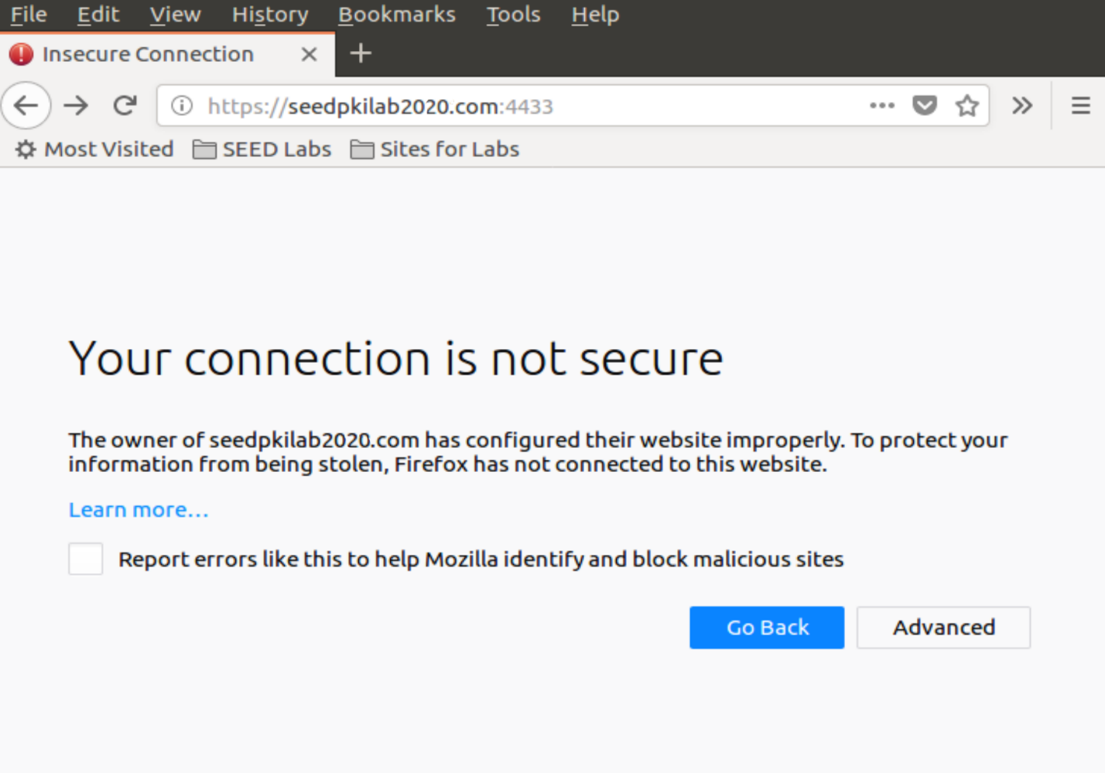

**Step 3: Getting the browser to accept our CA certificate.**

Search for "certificate" in Firefox's Preferences page, click on "View Certificates" and enter "certificate manager", click on "Authorities tab" and import CA.crt. Check "Trust this CA to identify web sites".

Reload <https://seedpkilab2020.com:4433/>.

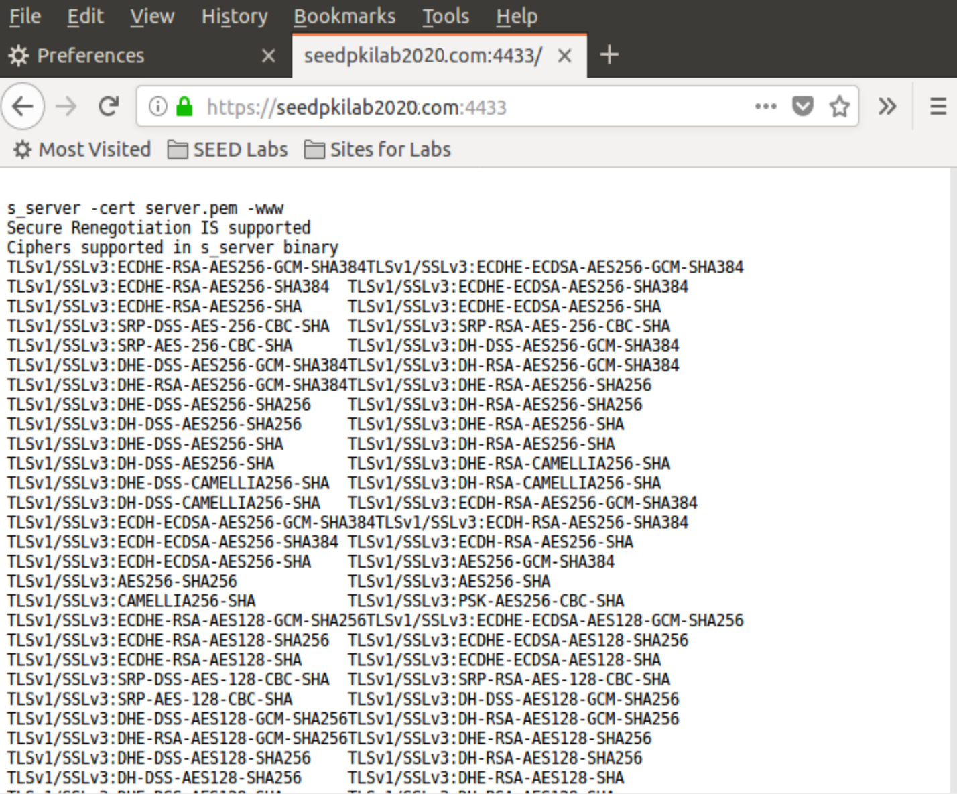

**Step 4. Testing our HTTPS website**

**Modify one byte in server.pem**

It's up to which byte you modify. Most bytes make no differences after corrupted. But some will make the certificate invalid.

**Use localhost**

When browsing https://localhost:4433, it is reported unsafe HTTPS

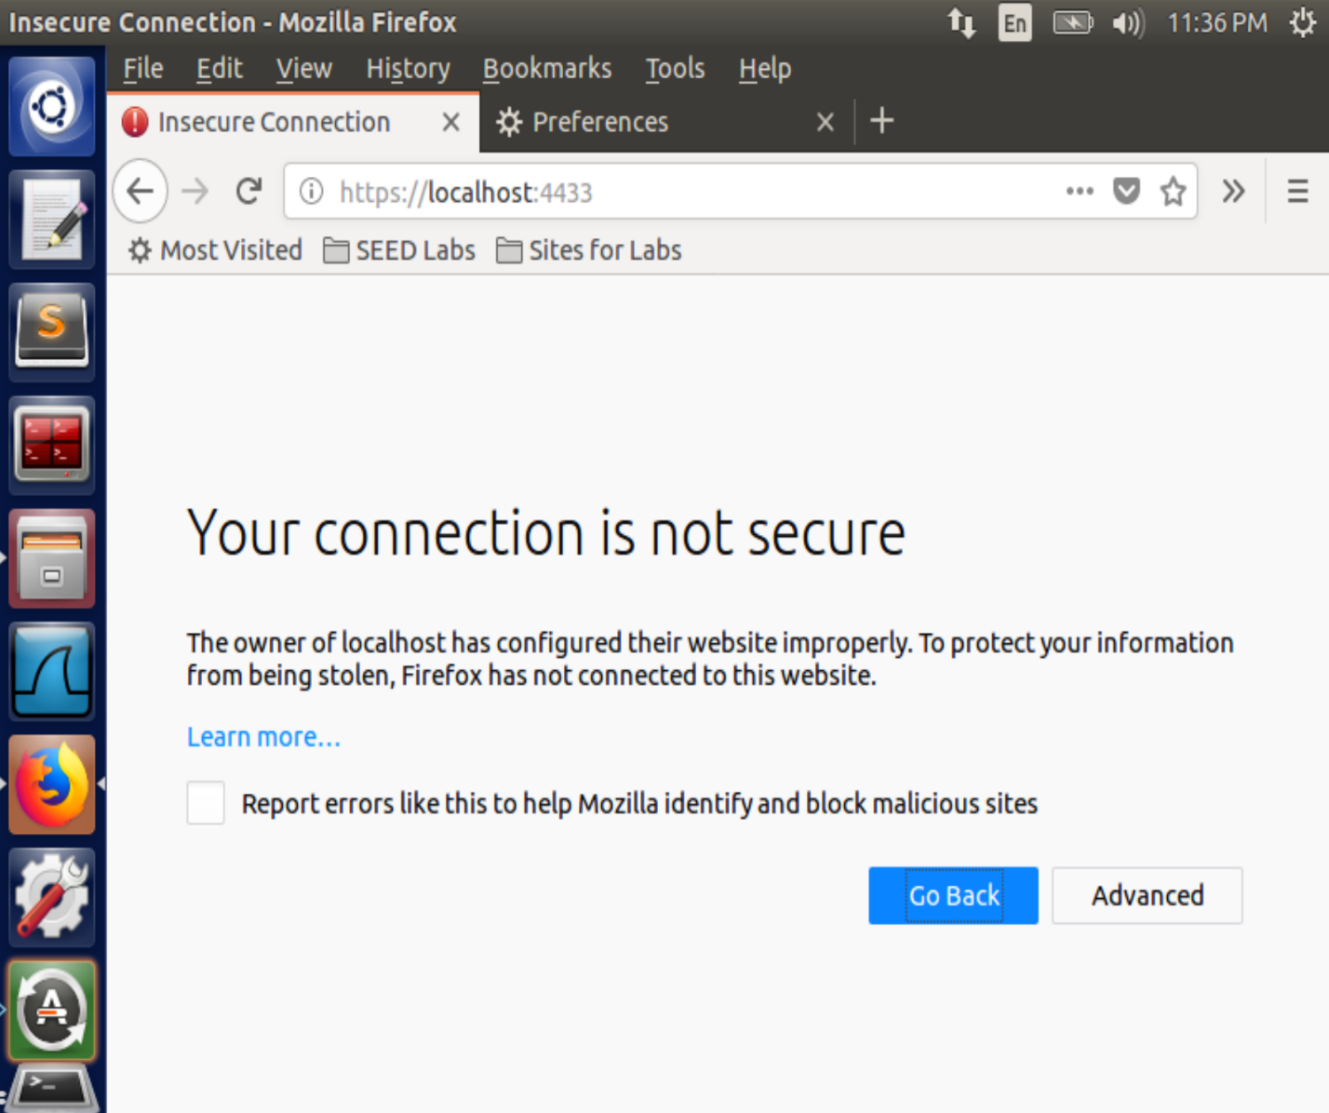

Because the locolhost has no certificate, the website is using a certificate identified for seedpkilab2020.com.

**Task 4: Deploying Certificate in an Apache-Based HTTPS Website**

Open configuration file of Apache HTTPS server:

sudo gedit /etc/apache2/sites-available/default-ssl.conf

Add the entry and save:

<VirtualHost *:443>

ServerName SEEDPKILab2020.com

DocumentRoot /var/www/pki

DirectoryIndex index.html

SSLEngine On

SSLCertificateFile /var/www/pki/server.crt

SSLCertificateKeyFile /var/www/pki/server.pem

</VirtualHost>

Copy the server certificate and private key to the folder:

sudo mkdir /var/www/pki

sudo cp server.pem server.crt /var/www/pki

Test the Apache configuration file for errors:

sudo apachectl configtest

Enable the SSL module:

sudo a2enmod ssl

Enable the site we have just edited:

sudo a2ensite default-ssl

Restart Apache:

sudo service apache2 restart

Once Apache runs properly, open <https://seedpkilab2020.com/>

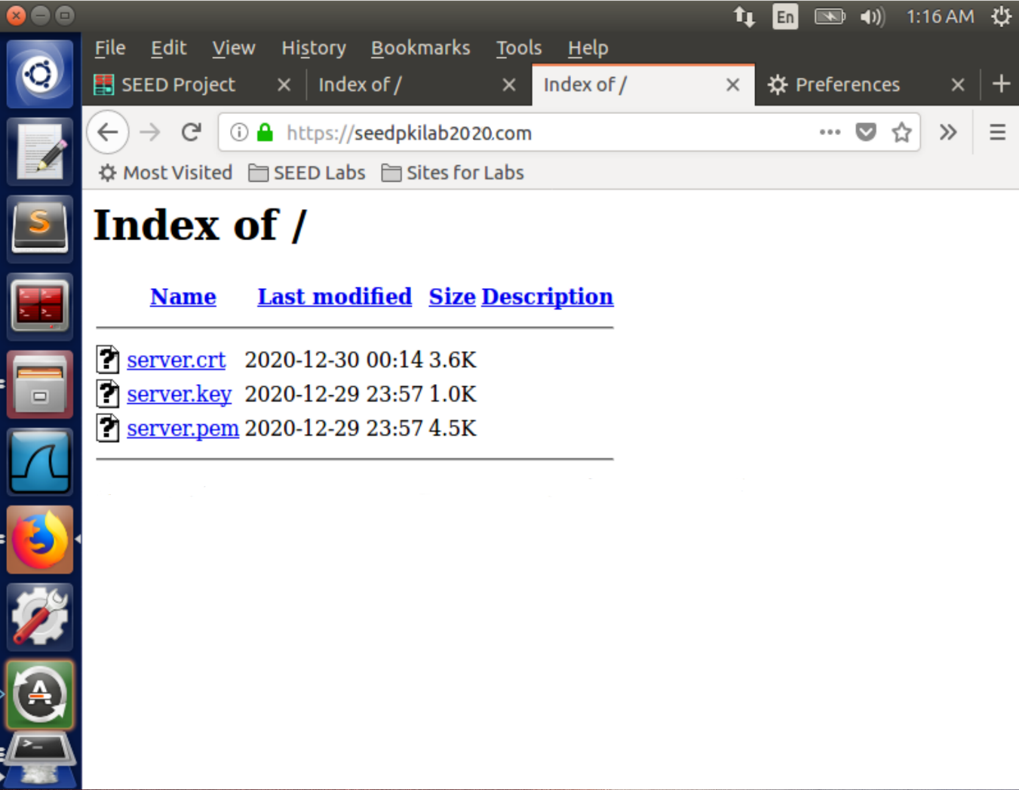

**Task 5: Launching a Man-In-The-Middle Attack**

Suppose we still use this VM (10.0.2.10) as the malicious server, start another VM (10.0.2.4) as the victim.

**Generate a certificate for example.com**

use a password (e.g. I use islander):

openssl genrsa -aes128 -out example.key 1024

Use example.com as the common name of the certificate request:

openssl req -new -key example.key -out example.csr -config openssl.cnf

openssl ca -in example.csr -out example.crt -cert ca.crt -keyfile ca.key \

-config openssl.cnf

cp example.key example.pem

cat example.crt >> example.pem

Copy the certificate and private key to the website root folder:

sudo mkdir /var/www/example

sudo cp example.crt example.pem /var/www/example

**Config and start the server**

On the server VM, open /etc/apache2/sites-available/default-ssl.conf and add the following entry:

<VirtualHost *:443>

ServerName example.com

DocumentRoot /var/www/example

DirectoryIndex index.html

SSLEngine On

SSLCertificateFile /var/www/example/example.crt

SSLCertificateKeyFile /var/www/example/example.pem

</VirtualHost>

Restart Apache:

sudo apachectl configtest

sudo service apache2 restart

**Config on Victim VM**

On the victim VM, modify /etc/hosts by:

sudo gedit /etc/hosts

add one line before the ending, which emulates a DNS cache positing attack:

10.0.2.10 example.com

To get the ca.crt, listen on a local port like:

nc -lvp 4444 > ca.crt

Then on the server VM, we send ca.crt by:

cat ca.crt | nc 10.0.2.4 4444

Once we receive the file on the victim VM, we install it on Firefox as [above](https://github.com/li-xin-yi/seedlab/tree/master/PKI#step-3-getting-the-browser-to-accept-our-ca-certificate).

Now, when browsing <https://example.com/>, the user on this VM actually visit the fake website launched by the malicious server:

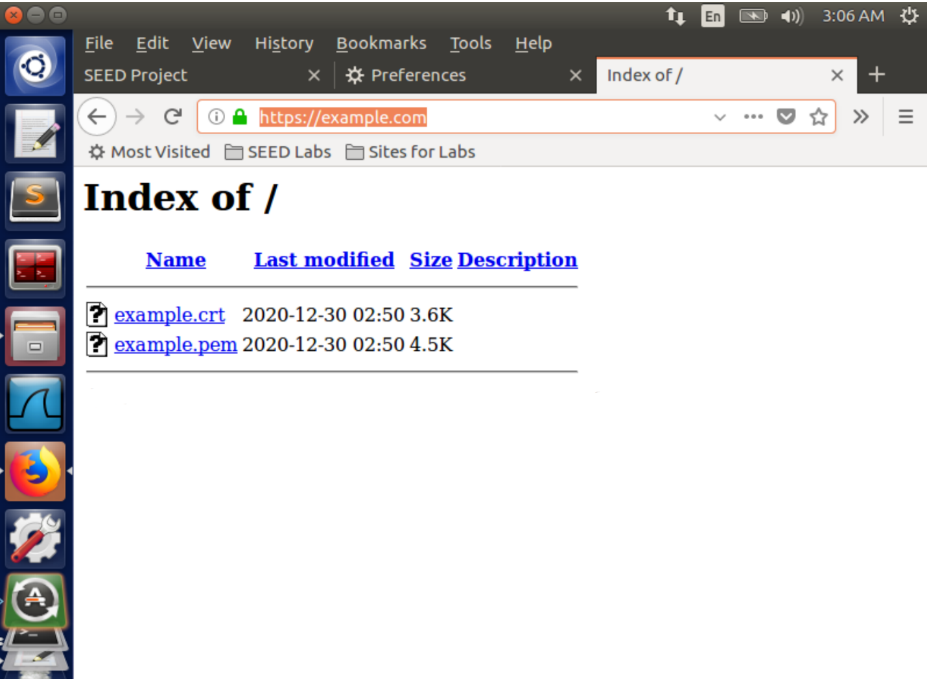

**Task 6: Launching a Man-In-The-Middle Attack with a Compromised CA**

Based on [Task 5](https://github.com/li-xin-yi/seedlab/tree/master/PKI#task-5), we can assume if the attacker stole ca.key, which indicates that he/she can easily generate the CA certificate ca.crt by the compromised key:

openssl req -new -x509 -keyout ca.key -out ca.crt -config openssl.cnf

Then, ca.crt can be used to sign any server's certificate, including the forged ones. The process of such attacks can be described as [what we did before](https://github.com/li-xin-yi/seedlab/tree/master/PKI#task-5), except that we don't even need to deploy the ca.crt on the victim machine because it has already installed the same ca.crt.